Name: Faisal Alsarmi

Course: 4426

Proposal and the outline of the game

**Basic Math Game for Kids**

# Table of Content

Table of Content 2

Abstract 3

Introduction 3

Funding 4

Appendix 5

Development environment .5

Game Design and Screenshots 5

Game Outline 9

# Abstract

# The teachers were all individuals in an as of late made Masters course that had been arranged with the purpose of propelling the change of consistent finding in the primary classroom as a noteworthy part of undertaking supported by the Scottish Government. The paper demonstrates the establishment of this movement inside the setting of the Scottish Curriculum for Excellence change. The particular thought is given to the epistemological arranging of the researchers as this influenced both the instructive projects design process and besides the theoretical encompassing of the examination consider which are both delineated. The wander was set up inside an arrangement inspect the structure, which intended to propel classroom-build action explore regarding a few individuals through the course and moreover ask about by the school investigators into the technique of instructive projects change. The investigation questions focused on the teachers' assurance, capacity, perspectives and feelings in association with number juggling and their wants and experiences of the impact on understudy taking in rising out of this course. Correct data were drawn from pre-and post-course studies, gatherings, and view of the discussion social affairs in the online condition. Disclosures from this examination highlight the way the course had a transformational and emancipatory influence on these instructors. They moreover include courses in which the 'restricting' of particular parts of the instructive modules severely influenced understudies in the ways that covered inventiveness and obliged the movement of understudy self-run the show. Furthermore, they highlight the courses in which some of these teachers had experienced science as a school subject in particularly negative ways, including lifted measures of 'agent fierceness' and of being named.

# Introduction

It exhibits the point of view of numerical fallibilism in light of a perspective of science as human action and on the suggestion that it is this human scientific action that produces arithmetic. Interestingly, he contends that Euclidean procedure built up a specific mandatory style of introduction, which he portrays as a deductivist style. Arithmetic is contrasted and a conjuring demonstration in which the understudy is obliged to acknowledge this without making inquiries about the first suspicions. In this deductivist style, under which all recommendations are valid, and all inductions legitimate, arithmetic is exhibited as a consistently expanding set of eternal, unchanging certainties. The establishment setting for this movement was the setting of the Scottish Curriculum for Excellence change that, consequently, has been arranged inside a full context of an all-inclusive study of the quality and estimation of guideline comes about coordinated by the Organization for Economic Cooperation and Development. This report highlighted the way that Scotland dependably performs at a selective necessity in OECD's Program for International Student Assessment and has a champion among the most fair-minded instructive frameworks in the OECD. It is like manner included two imperative troubles, the first of these being an achievement gap that opens up late in first preparing and enlarges through junior discretionary years with kids from poorer establishments being more plausible than others to underachieve. A minute test highlighted the need to fulfill broader and more productive participation in upper helper direction and more critical incentive in cutting edge training. The instructive projects in Scotland are non-statutory, and the Government's commitment is to give the structure to learning and teaching rather than to prescribe or endeavor to micromanage what happens in particular schools. The liability in regards to what is indicated rests steadily with neighborhood experts and institutions coordinating while at the same time surveying political tenets and appeal.

# Funding

In the Undergraduate recommendation are investigated by mathematicians at the NSA. The sheets meet each year to discuss, rank and demand the suggestions as demonstrated by the Principal Investigator's ability, legitimate authenticity and the full impact of the activities and event. The last asking for will be used by the NSA Mathematical Sciences Program Office to settle on financing decisions. In spite of the way that it is the arrangement of the NSA MSP that the examination it supports will convey merely unclassified results, it should be seen that investigation in sensitive extents may make information where exposure could hurt U.S. national security. Subsequently, the going with presentation methodology is participated in each NSA give, it is ordinary that the recipient may make an easygoing, open introduction of the intelligent and particular information coming to fruition in light of this Agreement, e.g., release articles for appropriate master preparations or present papers at consistent social events or symposia. The Performing Organization agrees to provide for the Government, synchronous with extensive exposure, a copy of such articles, reports, or information occurring in light of this work in guiding or social events of individuals, where appropriate, for encouraging exploration. On the off chance that the master trusts information delivered in the midst of the investigation may require arranging, the researcher may tell NSA and request that the information is examined. The social occasions should work expediently to survey the data and usually set up reasonable dealing with and disposition rules. This is the mind-blowing open entryway for informational programming along these lines. We can apply for a couple of accounts through this organization sponsoring or some practically identical setting up. Moreover, diversion can be made in future as the web application. That way, we can develop free shape (fundamentally essential features) and paid interpretation where a customer will get data about various distinctive things. Also in paid programming variation, we can offer customer to download a couple of headings about sustenance

# Appendix

## Development environment

Kids Math game was made using Java as programming tongue and Eclipse as making contraption. Java is an all-around valuable PC programming lingo that is synchronous, class-based, question organized and especially proposed to have a few use conditions as could be reasonable the situation being what it is. It is intended to give application architects "an opportunity to create once, run wherever" (WORA), inferring that joined Java code can continue running on all phases that assistance Java without the prerequisite for recompilation. Java applications are frequently amassed to bytecode that can keep running on any Java virtual machine (JVM) paying little regard to PC building; Java is a champion among the most unmistakable programming lingos being utilized.

## 

## Game Design and Screenshots



Figure 1 – Welcome Screen

Choosing View Medals or About button opens Information window as shown on figure 2.



Figure 2-

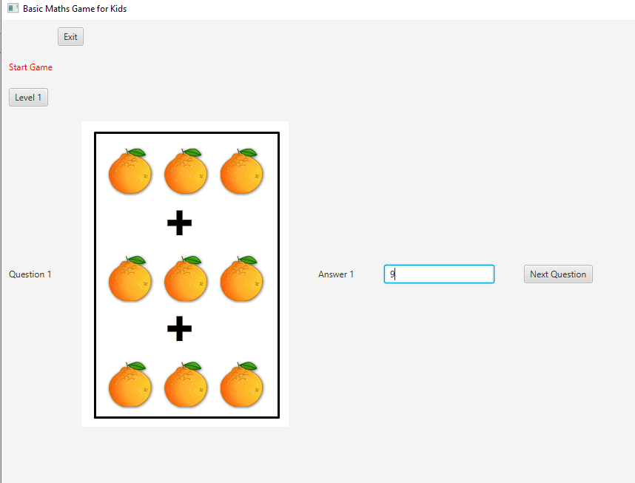

Figure 3

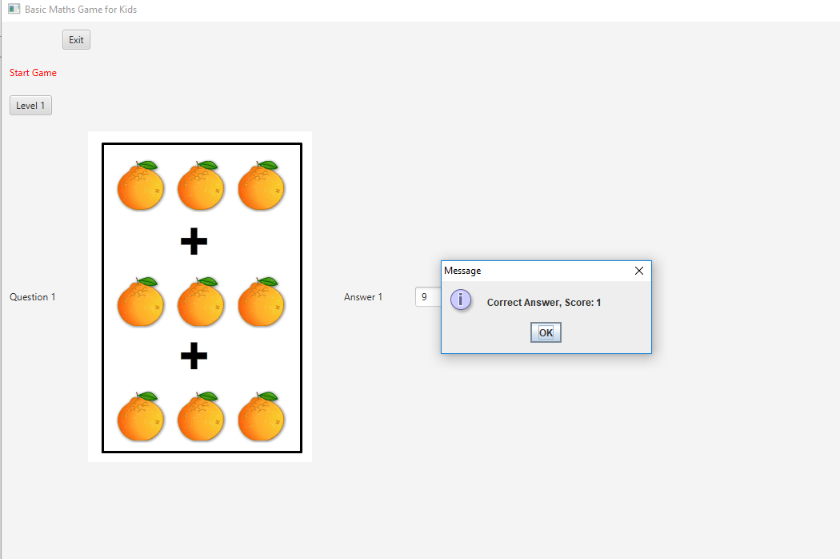

Figure 4

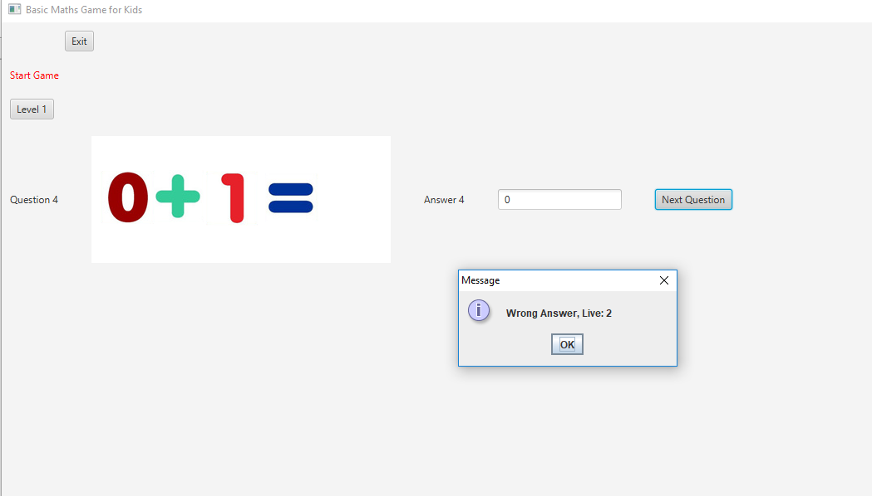

Figure 5

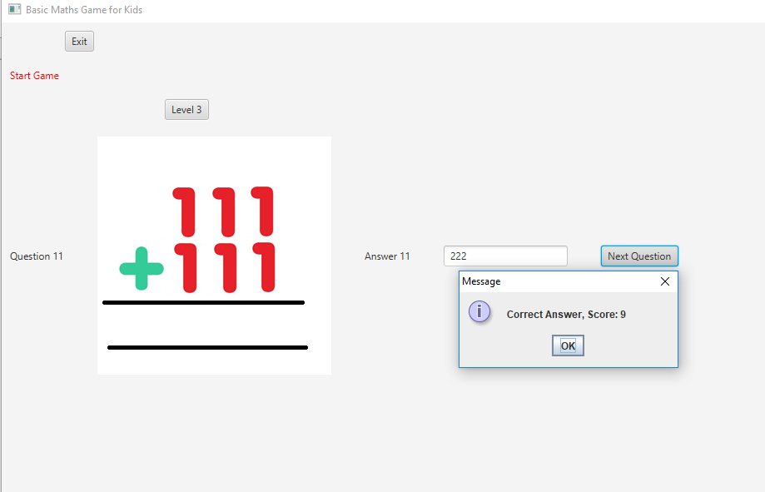

Figure 6

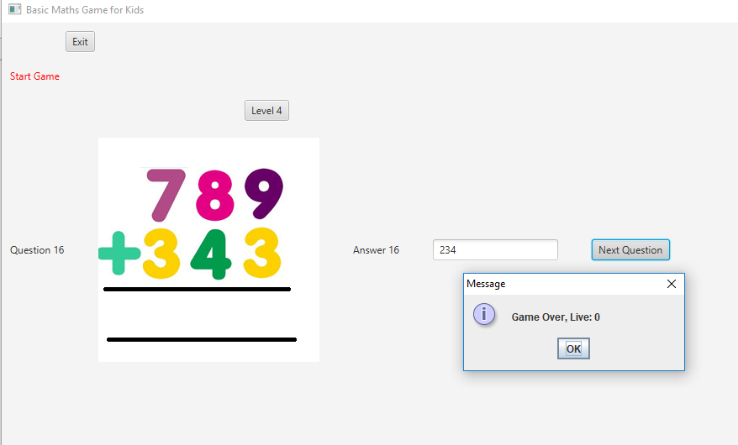

Figure 7

# 

# 

# Game Outline

## Controls:

First of all, run the program and login into the game, you can login without putting a password and username just made it easy to use. After login in into the game it will show the level one button, so you should press the button and you will play the level one which has 5 questions same as every level. Moreover, this game has 5 levels and each level has 5 questions as I mentioned before. Also each level has 3 lives, so if you answered wrong you will still have the chance to move to the next level and if you used all the 3 lives that you have, defiantly you will lose the game and the game will be over. Also this game will start easy at the level one and it will continue getting harder in each level you move to.